Objective

Versioning is the process of assigning a unique version number to a unique sates of a document or software product. It is use to keep track to the incremental development on a build process.

Scope

All documents or software products developed for the generation of a Help system for the BCH web site.

References
N/A

Definitions
N/A

Content

Development

This system has been planned to be developed in cycles, each one will be given a version number; these numbers are generally assigned in an increasing order and correspond to new developments cycles in the system

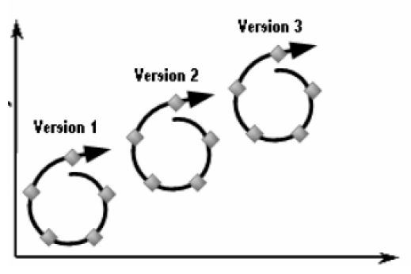
Functionalities
Time

Versioning scheme

The versioning scheme will be expressed with three numbers, separated by periods. i.e.

major.[minor.[revision]]

Major number is increased when there are significant jumps in functionality.

Minor: when only minor features or significant fixes have been added.

Revision: is incremented when minor functionalities or bugs are fixed.

